**GARAGE MANAGEMENT SYSTEM**

By

KOTA MOUNIKA

228x1a4274@khitguntur.ac.in

Username : 228x1a4274126@agentforce.com

**INTRODUCTION**

Project Overview

The Salesforce-based Garage Management System (GMS) is a CRM-based solution designed to manage core automotive repair shop operations such as appointment scheduling, service tracking, billing, inventory, and customer communication, all integrated within Salesforce. The system is tailored to provide a scalable and efficient environment for small to mid-sized garages, empowering them with tools typically available only to large businesses.

In recent years, the automotive service industry has undergone significant digital transformation. Traditional garages face mounting pressure to improve their operations, cut turnaround times, and offer a seamless customer experience. The GMS addresses these challenges by leveraging Salesforce's robust infrastructure to create a unified, cloud-based platform for garage management.

Purpose

To streamline and automate garage business operations, reduce manual tasks, enhance service quality, and provide a better customer experience through a centralized cloud-based platform. Additionally, the system is intended to improve data-driven decision-making and facilitate seamless communication across departments.

**IDEATION PHASE**

Problem Statement

Automotive garages struggle to maintain effective communication, appointment scheduling, and service tracking due to manual and fragmented systems. This leads to missed appointments, delayed services, and reduced customer satisfaction. A centralized, automated Garage Management System using Salesforce can enhance workflow efficiency, provide real-time data access, and improve customer service experiences. Traditional garage management is hindered by inefficiencies in booking, data handling, billing, and customer feedback due to the lack of integrated systems. These challenges reduce productivity and often result in poor customer experience.

Empathy Map

Empathy Map To better understand user needs, an empathy map was created for two persons: garage staff and customers.

**Garage Staff:**

* Think & Feel: Frustrated by disorganized records, want a smarter workflow.
* See: Manual entries and time-consuming tasks.
* Say & Do: Prefer tools that reduce repetitive work.
* Pain: Errors in billing and missed appointments.
* Gain: Efficiency, ease of communication, automated tracking.

**Customers:**

* Think & Feel: Desire quick, transparent service.
* See: Unclear service timelines and follow-ups.
* Say & Do: Frequently call to ask for updates.
* Pain: Delays and lack of status visibility.
* Gain: Appointment reminders, timely updates, and digital payments.

Brainstorming

The team initiated brainstorming sessions to identify key problems faced by vehicle service centers. Discussions revolved around operational bottlenecks such as appointment mismanagement, poor customer tracking, and inefficient service monitoring. Various ideas were explored, leading to the decision to develop a system that leverages Salesforce to automate and simplify garage operations. Visual diagrams and whiteboard mapping aided in conceptualizing the Garage Management System

Salesforce-based automation Appointment and billing flows Email alerts Role-specific access control Report and dashboard generation Customer feedback loop Integration with mobile devices

**INDEX PAGE**

|  |  |
| --- | --- |
| Task - 1 | Salesforce |
| Task - 2 | Object |
| Task - 3 | Tabs |
| Task - 4 | The Lightning App |
| Task - 5 | Fields |
| Task - 6 | Validation Rule |
| Task - 7 | Duplicate Rule |
| Task - 8 | Profiles |
| Task - 9 | Role & Role Hierarchy |
| Task - 10 | Users |
| Task - 11 | Public Groups |
| Task - 12 | Sharing Settings |
| Task - 13 | Flows |
| Task - 14 | Apex Trigger |
| Task - 15 | Reports |
| Task - 16 | Dashboards |

**Task – 1**

**Salesforce**

### **Creating Developer Account:**

1)To create a developer account in Salesforce, follow these steps:

2)Go to Salesforce Developer Signup.

Fill in the signup form with the following details:

* First name & Last name
* Email
* Role: Developer
* Company: College Name
* Country: India
* Postal Code: Pin code

3)Click Sign me up

.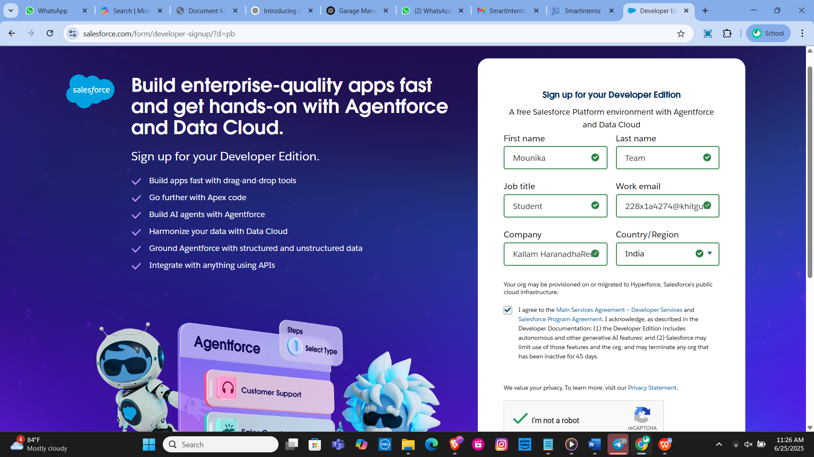

**Activating the Account**

Check the inbox of the email you used for signup.

Click on the verification link to activate your account (the email may take 5-10 minutes to arrive).

Click on Verify Account.

Set a password and answer a security question.

Click on Change Password.

You will be redirected to your Salesforce setup page.

**TASK – 2**

Object

**Creating the Custom Objects:**

This report outlines the steps to create various custom objects in Salesforce, specifically for a Garage Management System. The objects include Customer Details, Appointments, Service Records, and Billing Details and Feedback. These objects will help streamline operations and improve data management within the system.

Customer Details Object

Navigation Path: From the setup page, click on Object Manager >> Create >> Custom Object.

Details:

Label Name: Customer Details

Plural Label Name: Customer Details

Record Name: Customer Name

Data Type: Text

Options: Allow reports, Track Field History, Allow search

Save: Click Save to create the object

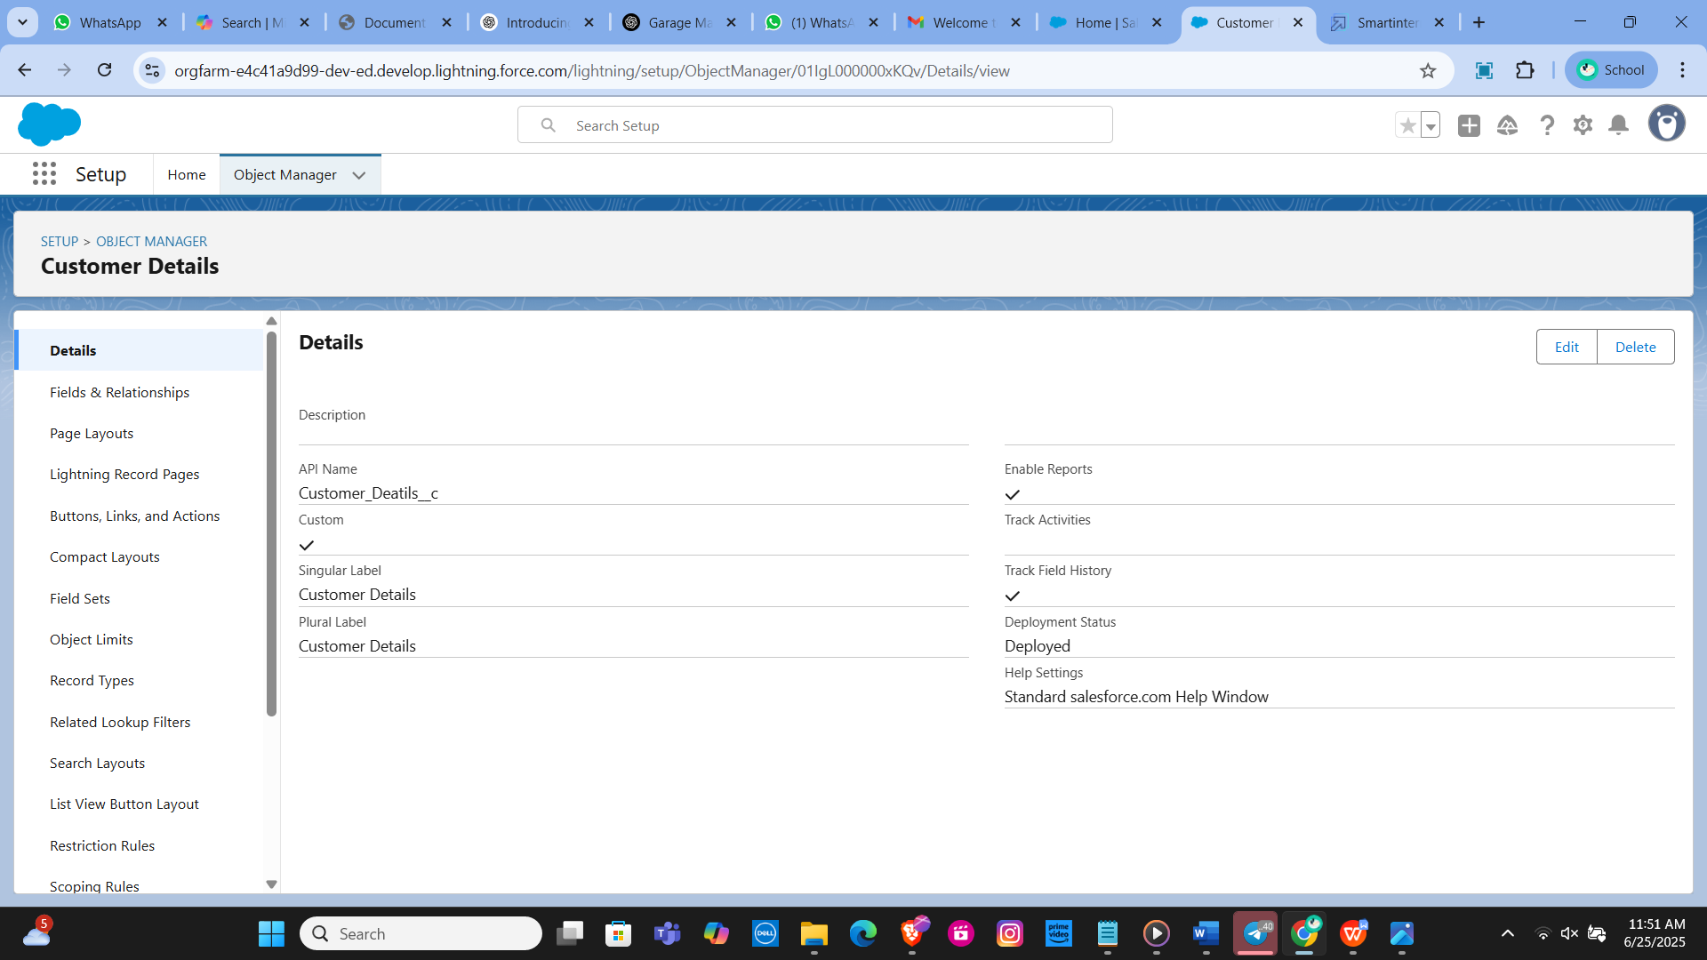

Appointment Object

Navigation Path: From the setup page, click on Object Manager >> Create >> Custom Object.Details:

Label Name: Appointment

Plural Label Name: Appointments

Record Name: Appointment Name

Data Type: Auto Number

Display Format: app - {000}

Starting Number: 1

Options: Allow reports, Track Field History, Allow search

Save: Click Save to create the object.

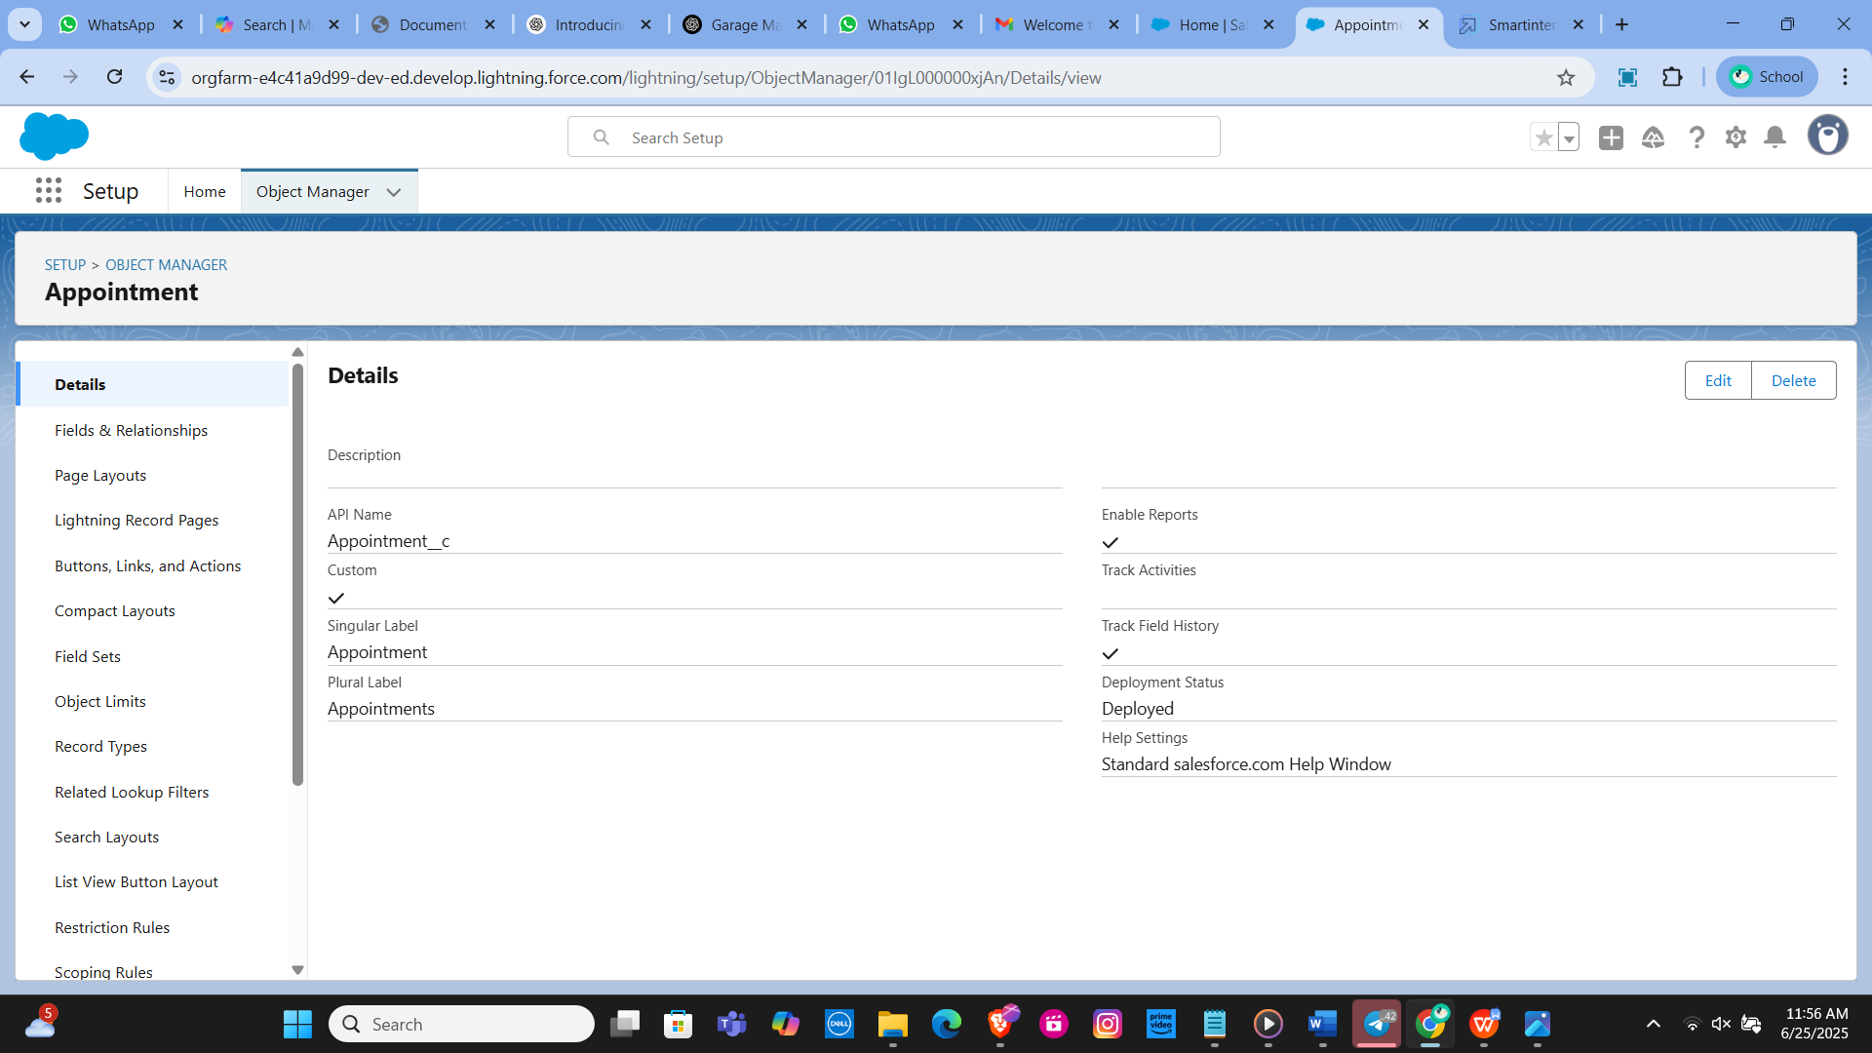

Service Records Object

Navigation Path: From the setup page, click on Object Manager >> Create >> Custom Object.

Details:

Label Name: Service Records

Plural Label Name: Service Records

Record Name: Service Records Name

Data Type: Auto Number

Display Format: ser - {000}

Starting Number: 1

Options: Allow reports, Track Field History, Allow search

Save: Click Save to create the object.

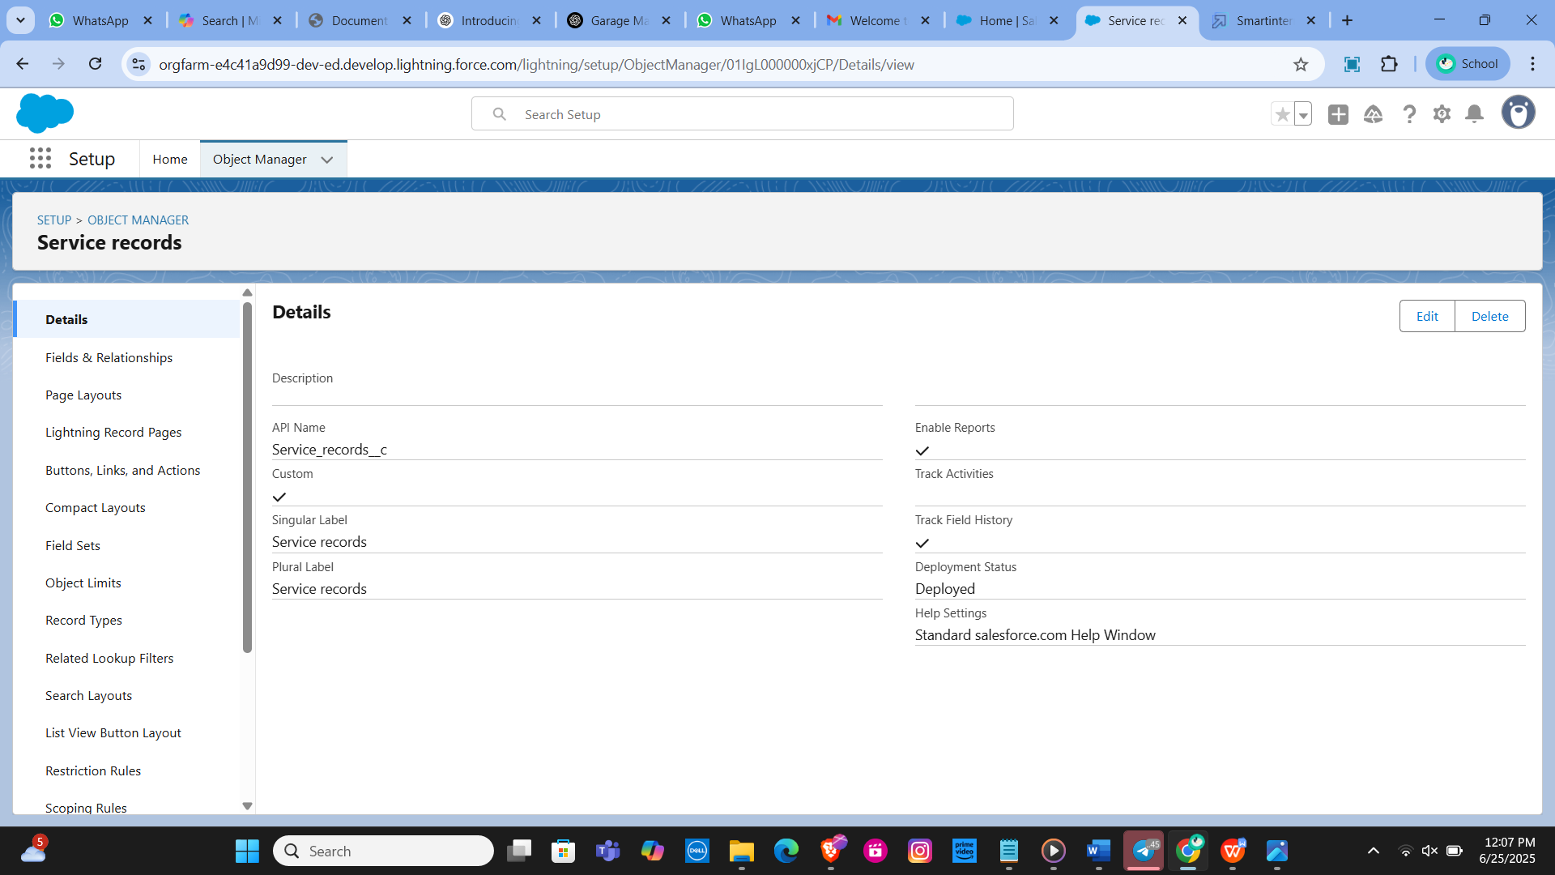

Billing Details and Feedback Object

Navigation Path: From the setup page, click on Object Manager >> Create >> Custom Object.

Details:

Label Name: Billing Details and Feedback

Plural Label Name: Billing Details and Feedback

Record Name: Billing Details and Feedback Name

Data Type: Auto Number

Display Format: bill - {000}

Starting Number: 1

Options: Allow reports, Track Field History, Allow search

Save: Click Save to create the object.

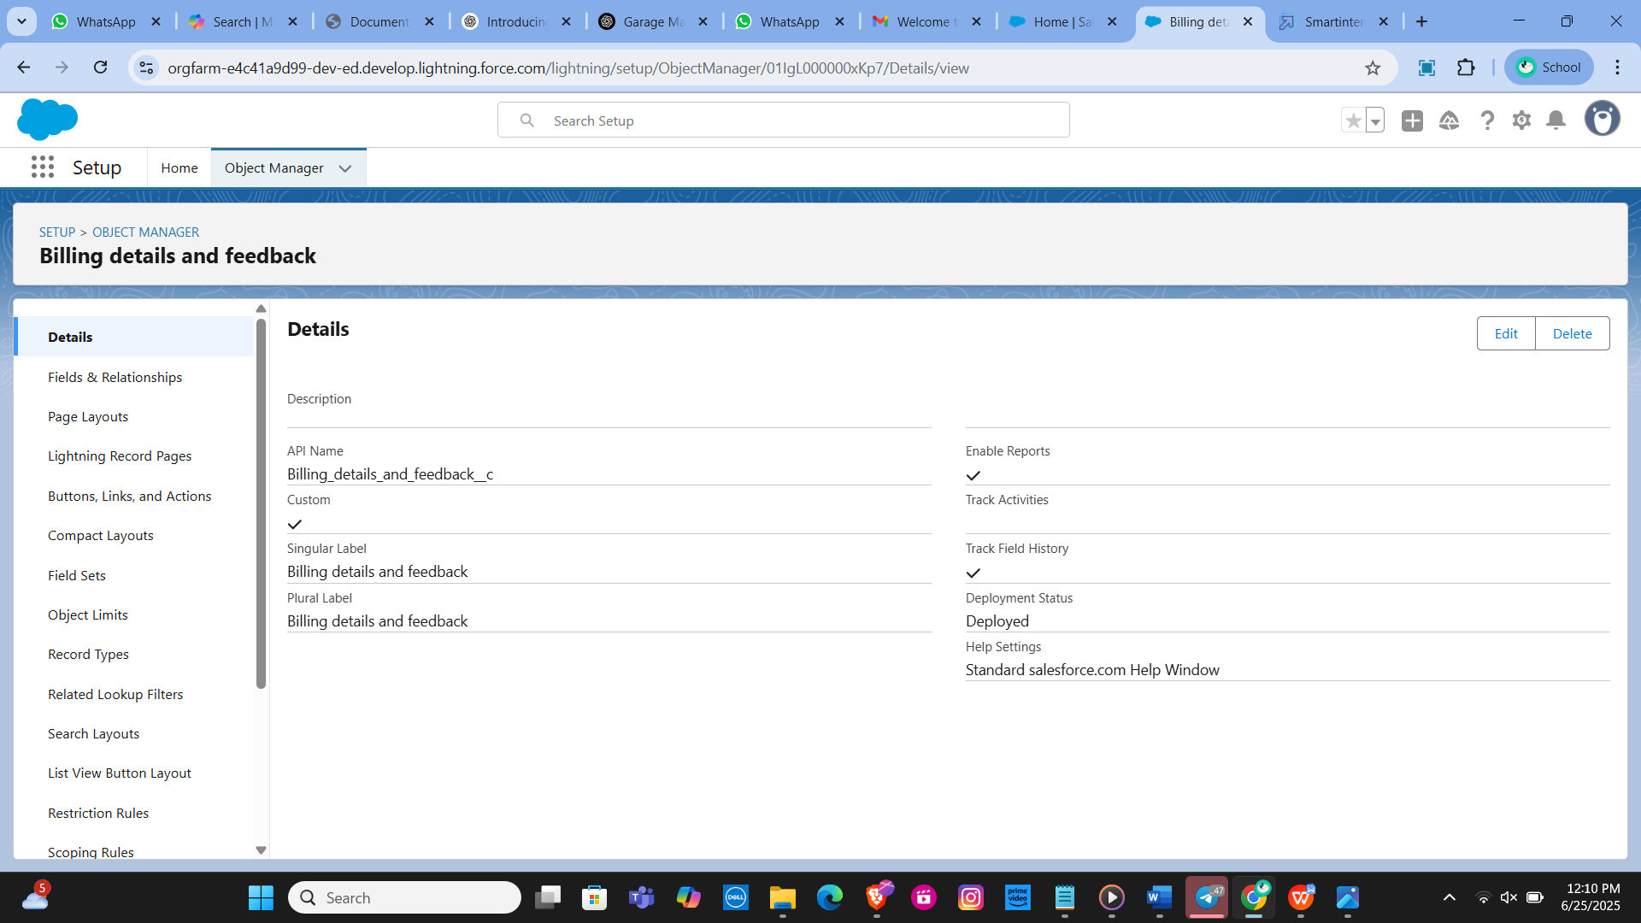

**Task – 3**

Creating a Custom Tab

Creating a Custom Tab for Customer Details

Navigation Path:

Go to the setup page.

Type "Tabs" in the Quick Find bar.

Click on "Tabs".

Click on "New" under the Custom Object Tabs.

Details:

Select Object: Customer Details

Select Tab Style: Choose a style that represents Customer Details.

Click Next.

Add to Profiles Page: Keep the default settings.

Click Next.

Add to Custom App: Uncheck "Include Tab".

Ensure "Append tab to users' existing personal customizations" is checked.

Click Save.

Creating Remaining Tabs (Appointments, Service Records, Billing Details and Feedback)

Repeat the above steps for each remaining object: Appointments, Service Records, and Billing Details and Feedback.

Navigation Path:

Go to the setup page.

Type "Tabs" in the Quick Find bar.

Click on "Tabs".

Click on "New" under the Custom Object Tabs.

Details for Each Object:

Select Object: Choose the respective object (Appointments, Service Records, Billing Details and Feedback).

Select Tab Style: Choose a suitable style for each object.

Click Next.

Add to Profiles Page: Keep the default settings.

Click Next.

Add to Custom App: Uncheck "Include Tab".

Ensure "Append tab to users' existing personal customizations" is checked.

Click Save.

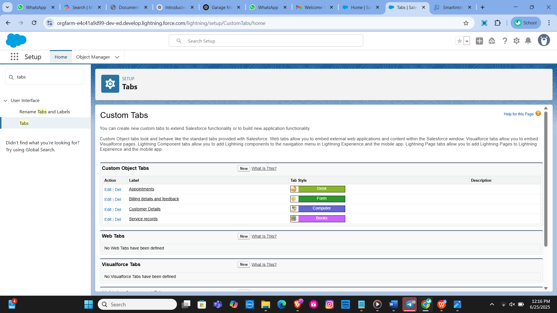

**Task - 4**

Building Lighting App

Creating a Lightning App in Salesforce for managing garage operations allows for streamlined processes and efficient management of various business aspects. This guide outlines the steps to create the Garage Management Application, including adding essential navigation items and user profiles.

**Creating a Lightning App**

Steps to Create a Lightning App

Accessing App Manager:

Begin by navigating to the setup page. In the Quick Find bar, search for "App Manager" and select it. Click on "New Lightning App" to start the creation process.

App Details:

Enter the name "Garage Management Application" in the app details. Proceed to the next steps, keeping all settings on the App Options and Utility Items pages as default.

Adding Navigation Items:

To enhance navigation within the app, select essential items such as Customer Details, Appointments, Service Records, Billing Details and Feedback, Reports, and Dashboards from the search bar. Move these items using the arrow button to include them in the app’s navigation menu.

Assigning User Profiles:

To ensure appropriate access and functionality, search for the "System Administrator" profile in the search bar. Add this profile by clicking the ar button. Complete the setup by saving and finishing the configuration.

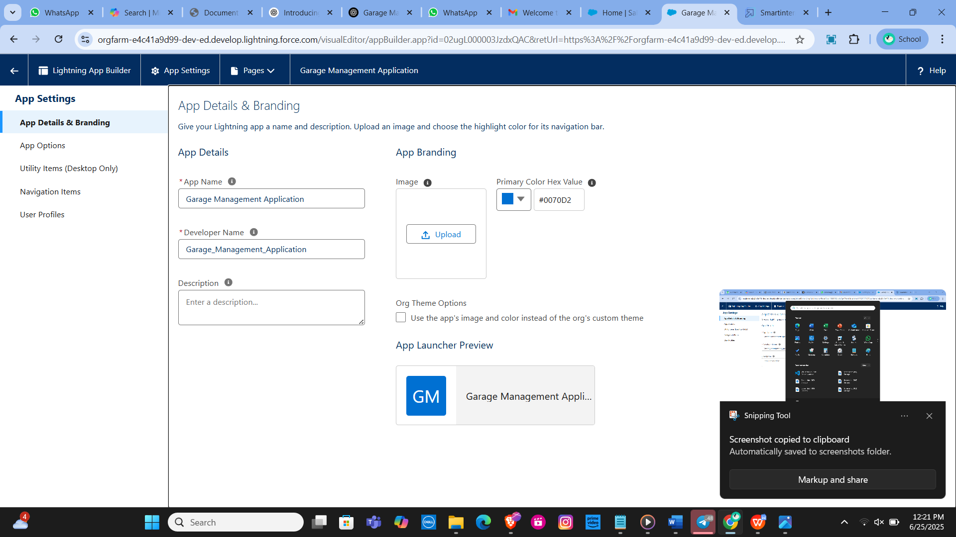

**Task - 5**

Creating Fields

**Customer Details Object Fields**

Phone Field: Created a phone field labeled "Phone Number" to store customer contact numbers.

Email Field: Added an email field labeled "Gmail" to capture customer email addresses.

**Lookup Fields**

Appointment Object: Established a lookup relationship field to link appointments to customer details, ensuring appointments are associated with the correct customer.

Service Records Object: Create a lookup relationship field to link service records to appointments. Added a filter to ensure the appointment date is less than the created date, making it a required field with error validation.

Billing Details and Feedback Object: Added a lookup relationship field to connect billing details and feedback with service records.

**Checkbox Fields**

Appointment Object: Added multiple checkbox fields to indicate different services, including "Maintenance Service," "Repairs," and "Replacement Parts," all with default values set to unchecked.

Service Records Object: Created a checkbox field labeled "Quality Check Status" to track the quality check status of the service records.

**Date Fields**

Appointment Object: Added a date field labeled "Appointment Date" and marked it as required to ensure each appointment has a specified date.

**Currency Fields**

Appointment Object: Created a currency field labeled "Service Amount" to record the cost of services provided, with read-only access for all profiles.

Billing Details and Feedback Object: Added a currency field labeled "Payment Paid" to track payments made by customers.

**Text Fields**

Appointment Object: Created a text field labeled "Vehicle Number Plate" with a length of 10 characters, marked as required and unique for vehicle identification.

Billing Details and Feedback Object: Added a text field labeled "Rating for Service" with a length of 1 character, required and unique to capture customer ratings.

**Picklist Fields**

Service Records Object: Created a picklist field labeled "Service Status" with values "Started" and "Completed" to track the progress of services.

Billing Details and Feedback Object: Added a picklist field labeled "Payment Status" with values "Pending" and "Completed" to monitor payment statuses.

**Formula Fields**

Service Records Object: Created a formula field labeled "Service Date" to automatically populate with the created date of the record

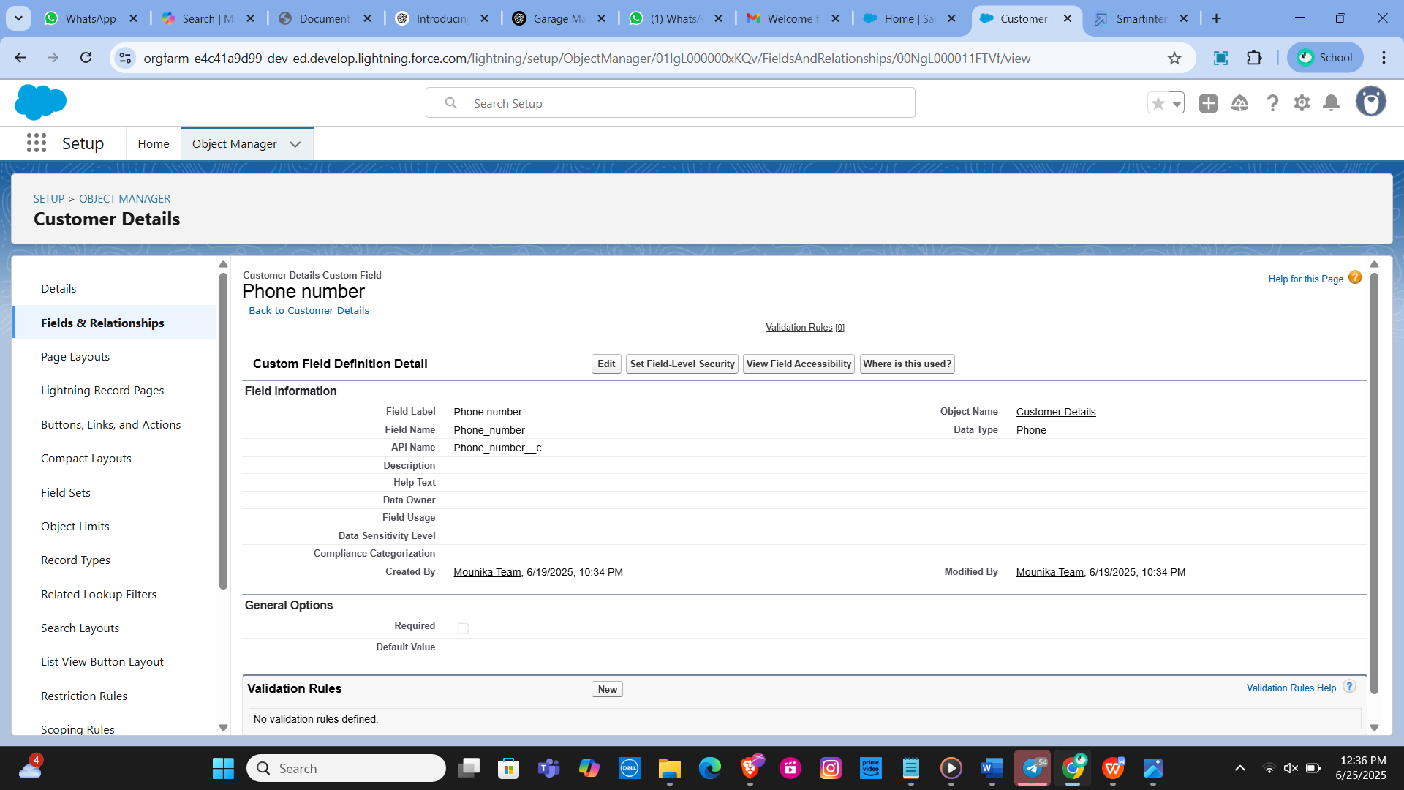

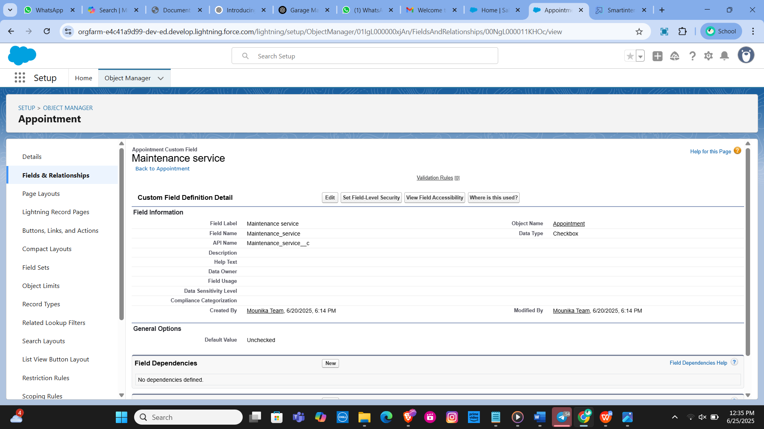

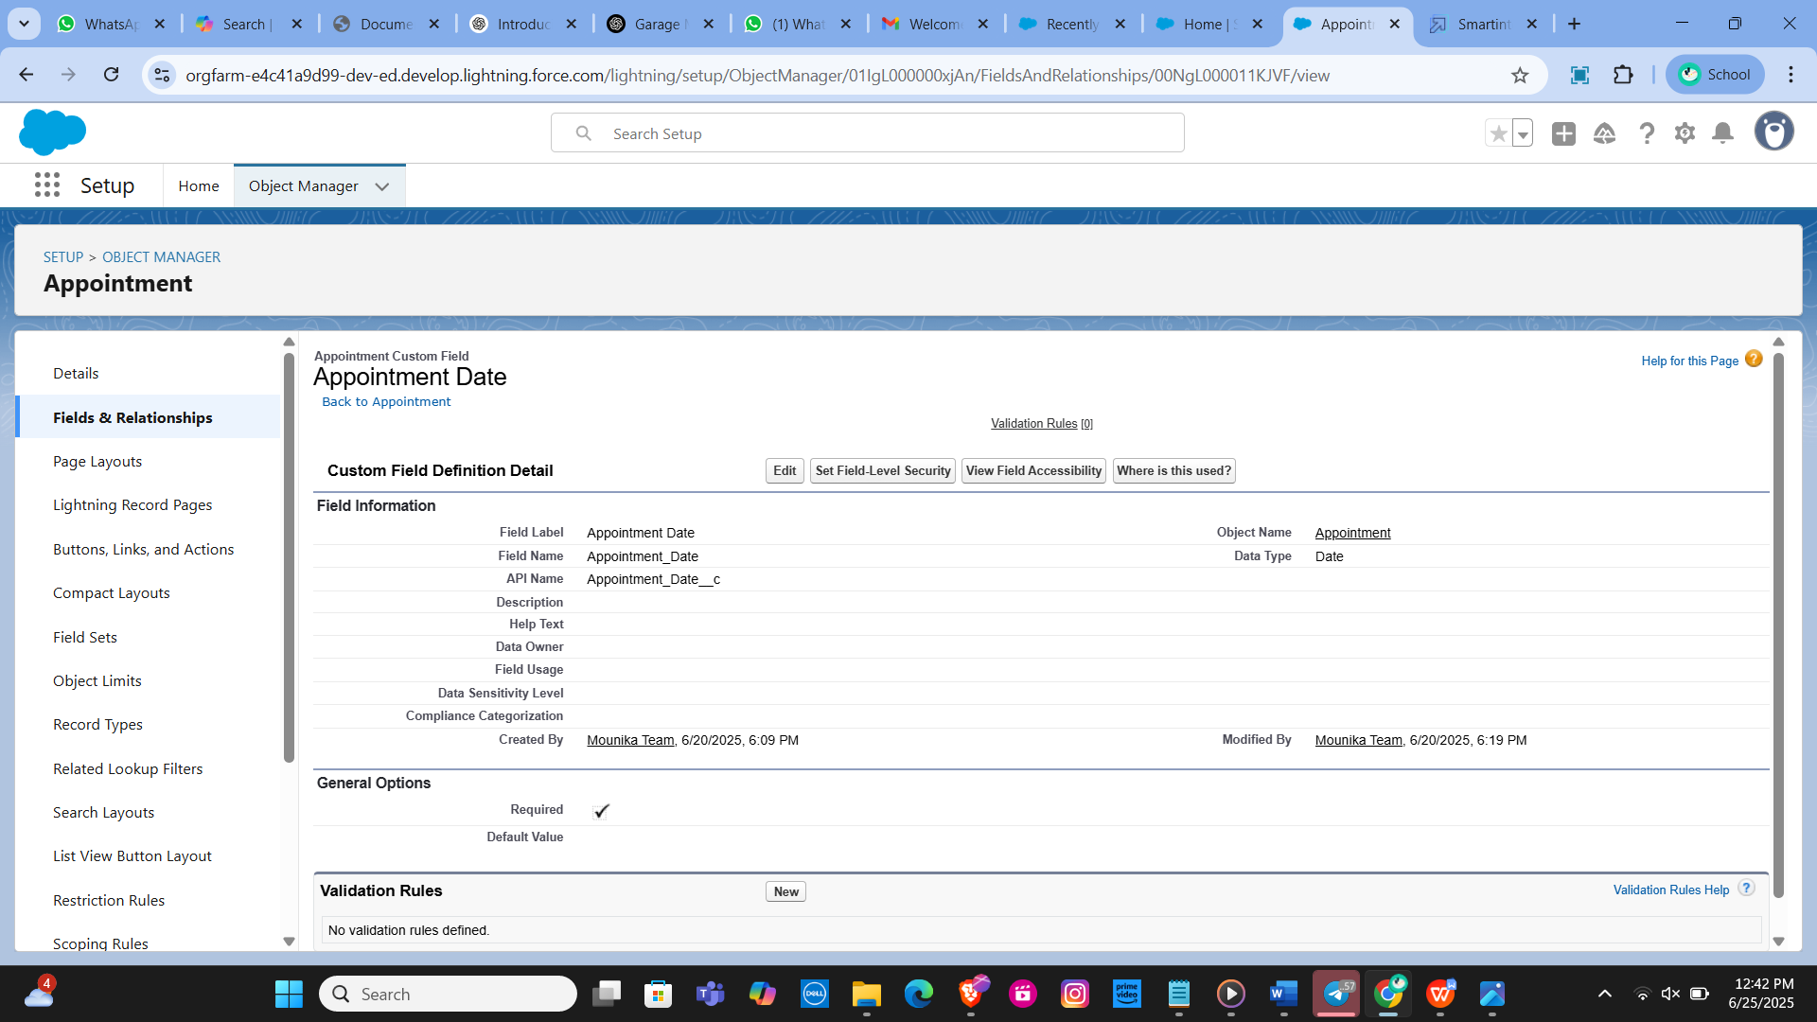

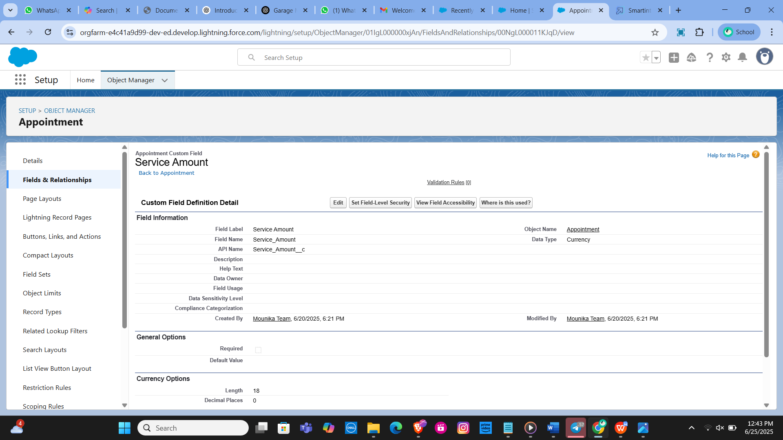

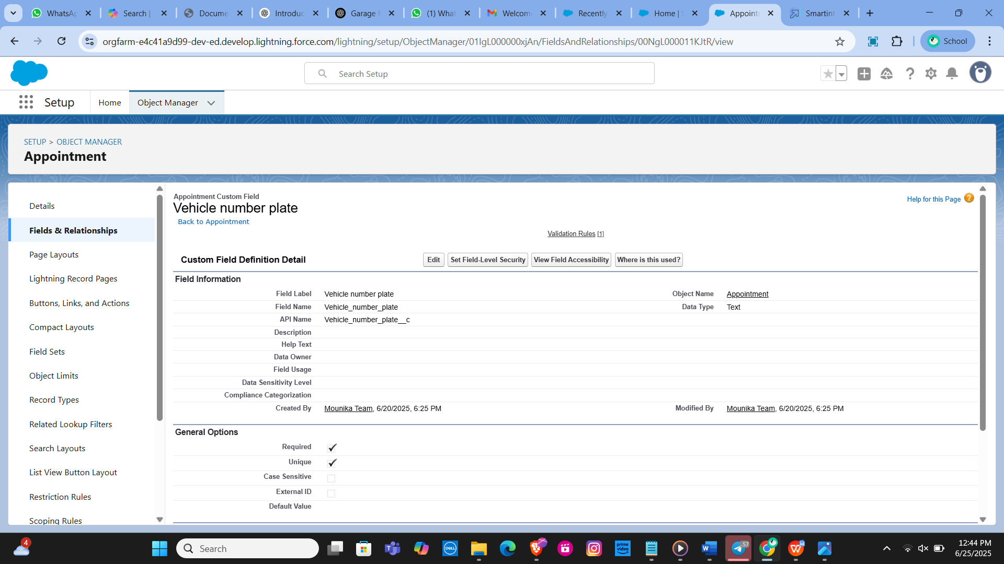

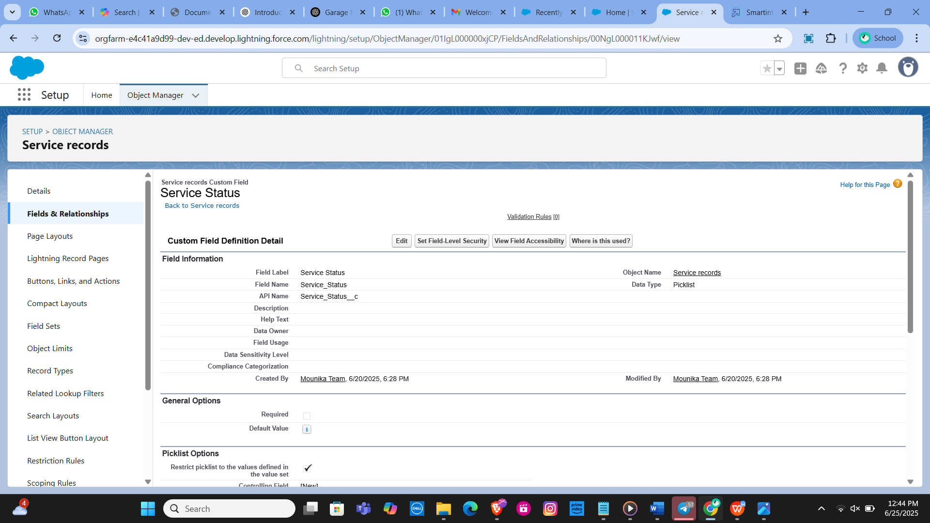

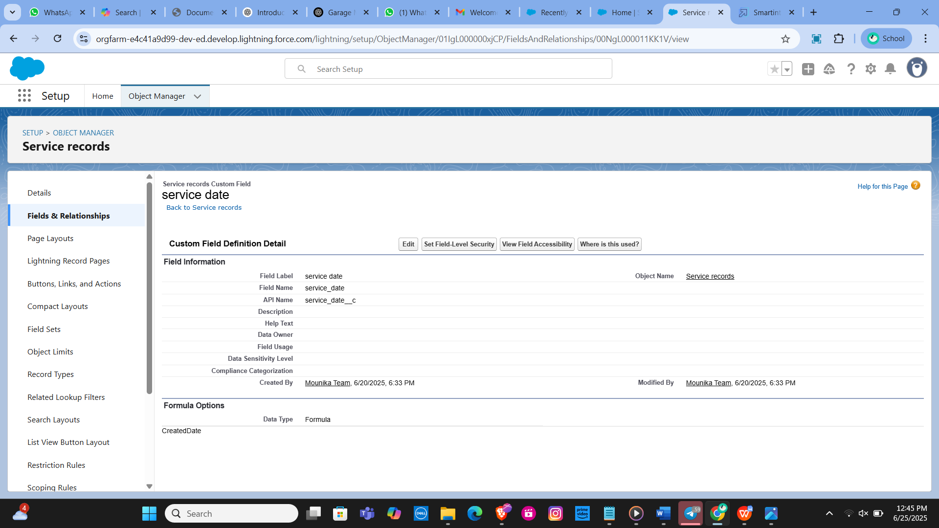

**Task - 6**

Validation Rules

**Validation Rule for Appointment Object**

Rule Name: Vehicle

Purpose: Ensure that the vehicle number plate follows a specific format.

Error Condition Formula: NOT(REGEX(Vehicle_number_plate__c , "[A-Z]{2}[0-9]{2}[A-Z]{2}[0-9]{4}"))

Error Message: "Please enter a valid number" Error Location: Field - Vehicle number plate

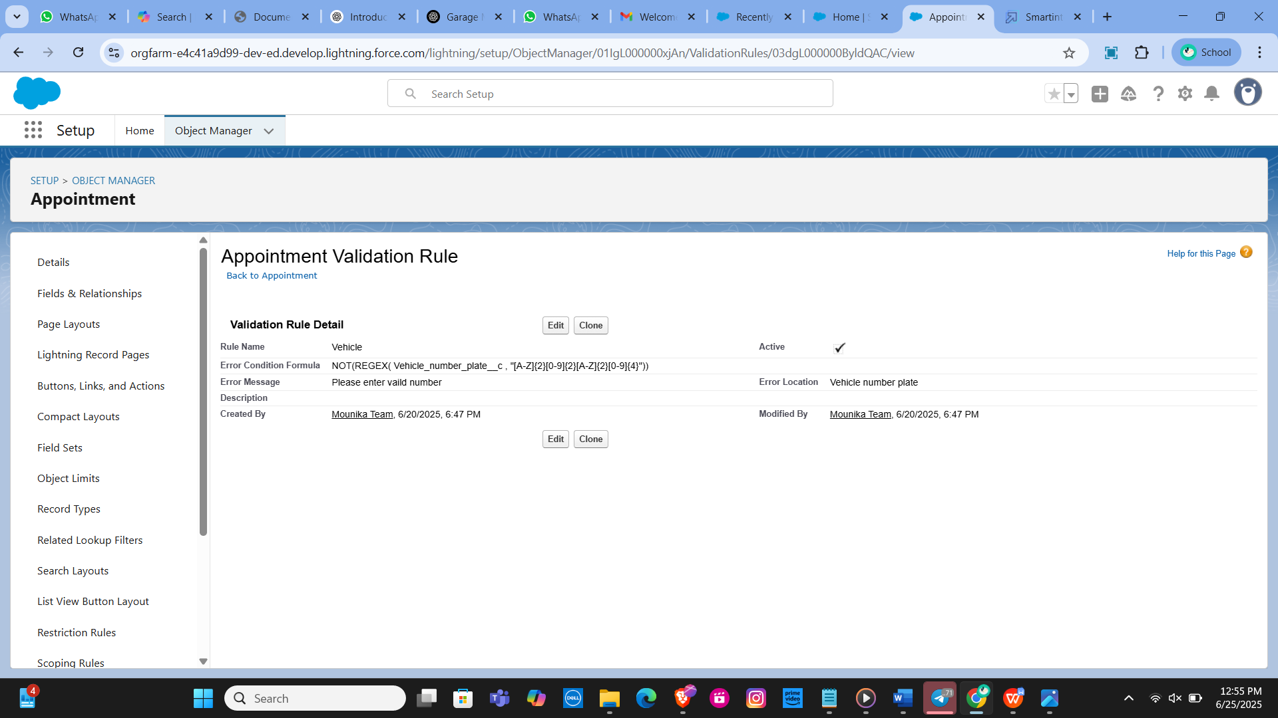

**Validation Rule for Billing Details and Feedback Object**

Rule Name: rating_should_be_less_than_5

Purpose: Ensure that the rating for service is between 1 and 5.

Error Condition Formula: NOT(REGEX(Rating_for_service__c, "[1-5]{1}"))

Error Message: "Rating should be from 1 to 5" Error Location: Field - Rating for Service

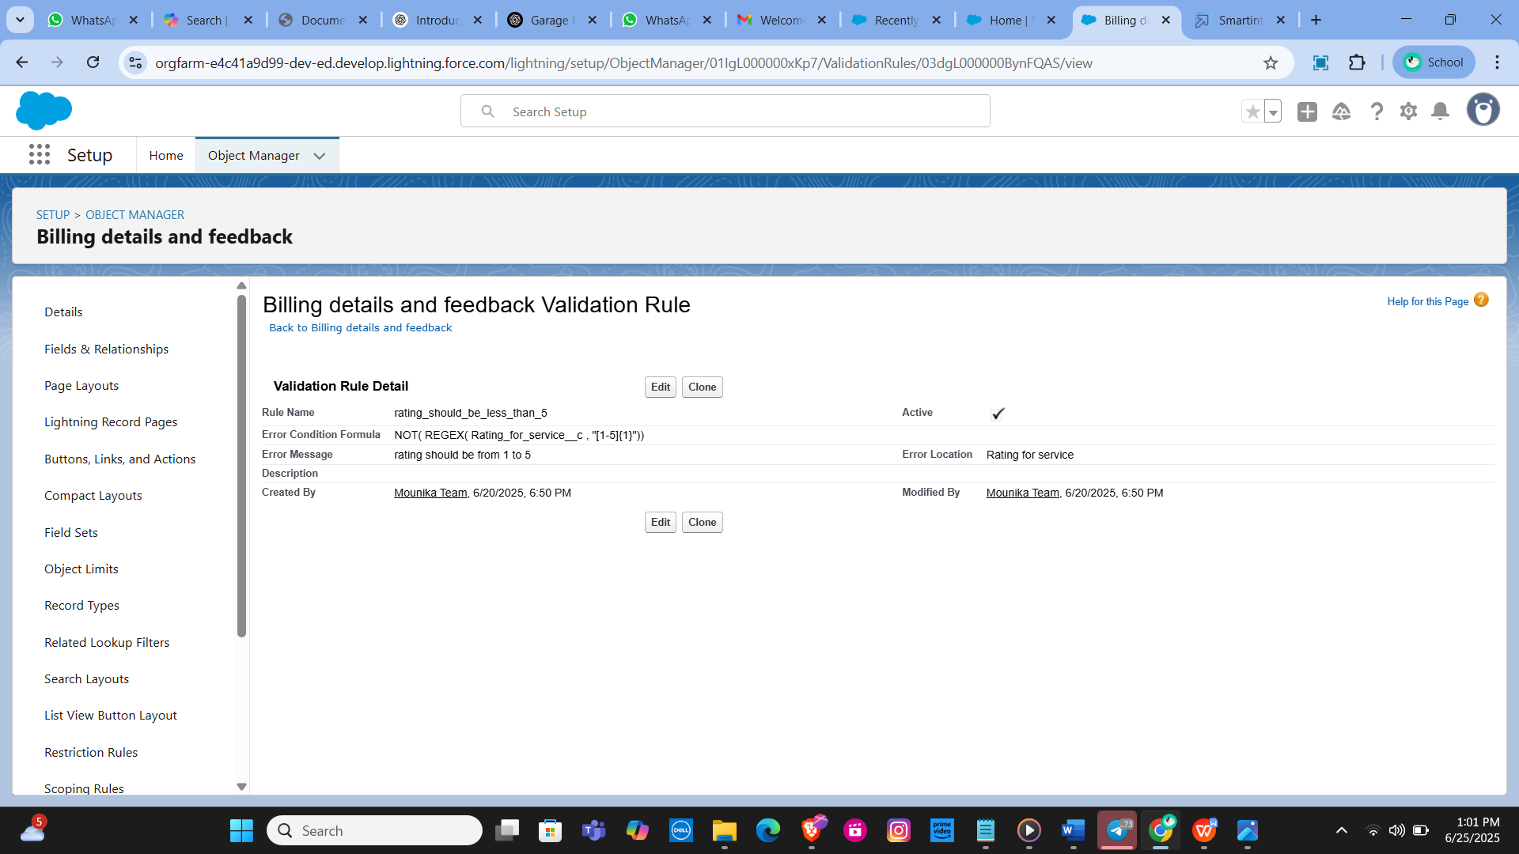

**Task - 7**

Duplicate Rule

Creating a Matching Rule for Customer Details Object

1. Rule Name: Matching Customer Details

Object: Customer Details

Matching Criteria:

Gmail: Exact match

Phone Number: Exact match

Activation: Once the rule is saved, it is activated to start matching customer details based on the specified criteria.

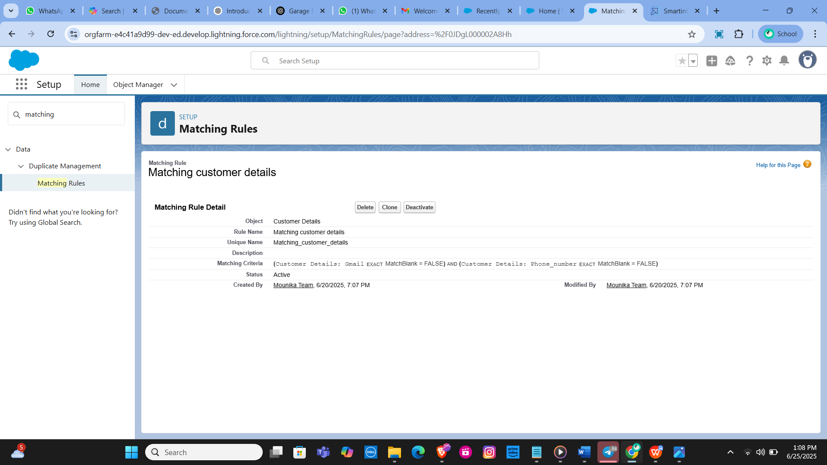

Creating a Duplicate Rule for Customer Details Object

Rule Name: Customer Detail

Duplicate Object: Customer Details

Matching Rule: Utilizes the previously created "Matching Customer Details" rule. Activation: After saving the duplicate rule, it is activated to begin identifying duplicate customer details based on the matching criteria.

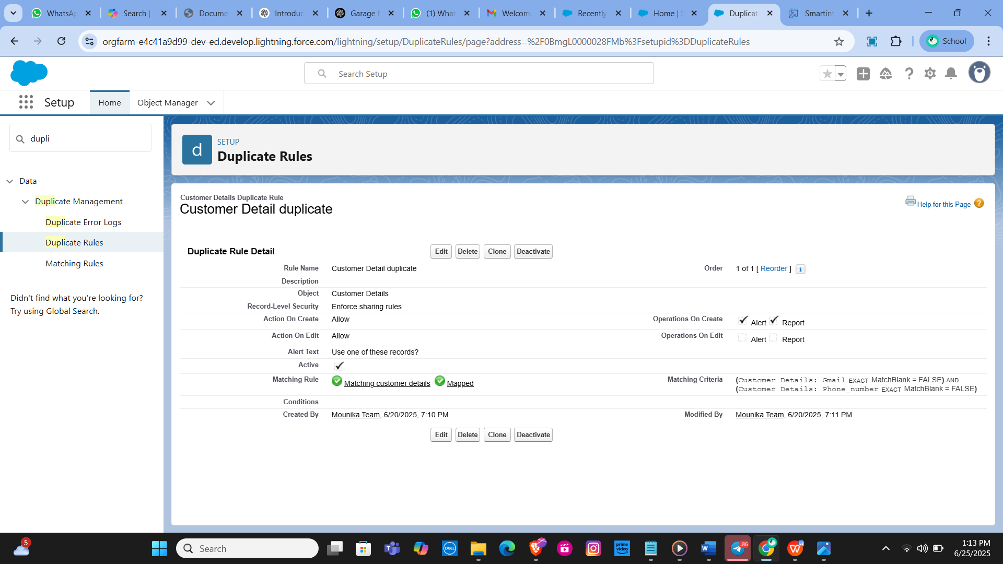

**Task - 8**

Profiles

**Creating the Manager Profile**

Profile Cloning:

Clone the Standard User profile to create a new profile named "Manager."

Custom App Settings:

Set the Garage Management Application as the default custom app for the Manager profile.

Custom Object Permissions:

Grant access permissions for the following objects:

Appointments

Billing Details and Feedback

Service Records

Customer Details

Session Timeout:

Configure the session timeout to occur after 8 hours of inactivity.

Password Policies:

Set user passwords to never expire.

Establish a minimum password length of 8 characters.

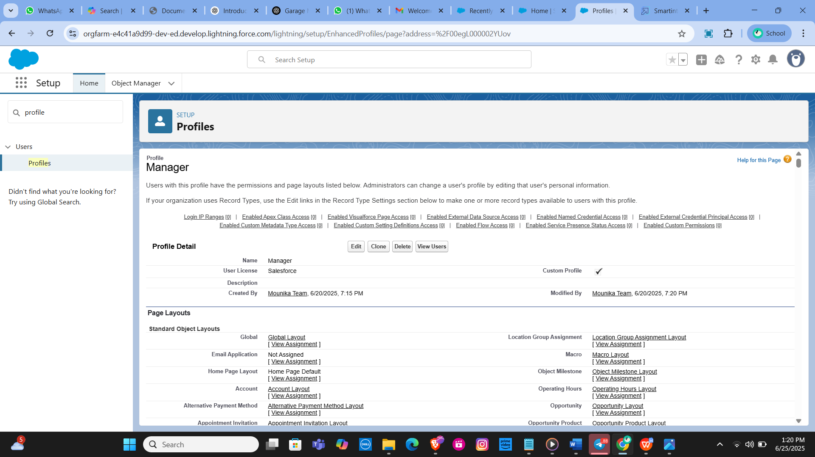

**Creating the Sales Person Profile**

Profile Cloning:

Clone the Salesforce Platform User profile to create a new profile named "Sales Person."

Custom App Settings:

Set the Garage Management Application as the default custom app for the Sales Person profile.

Custom Object Permissions:

Grant access permissions for the following objects: Appointments, Billing Details and Feedback, Service Records, Customer Details

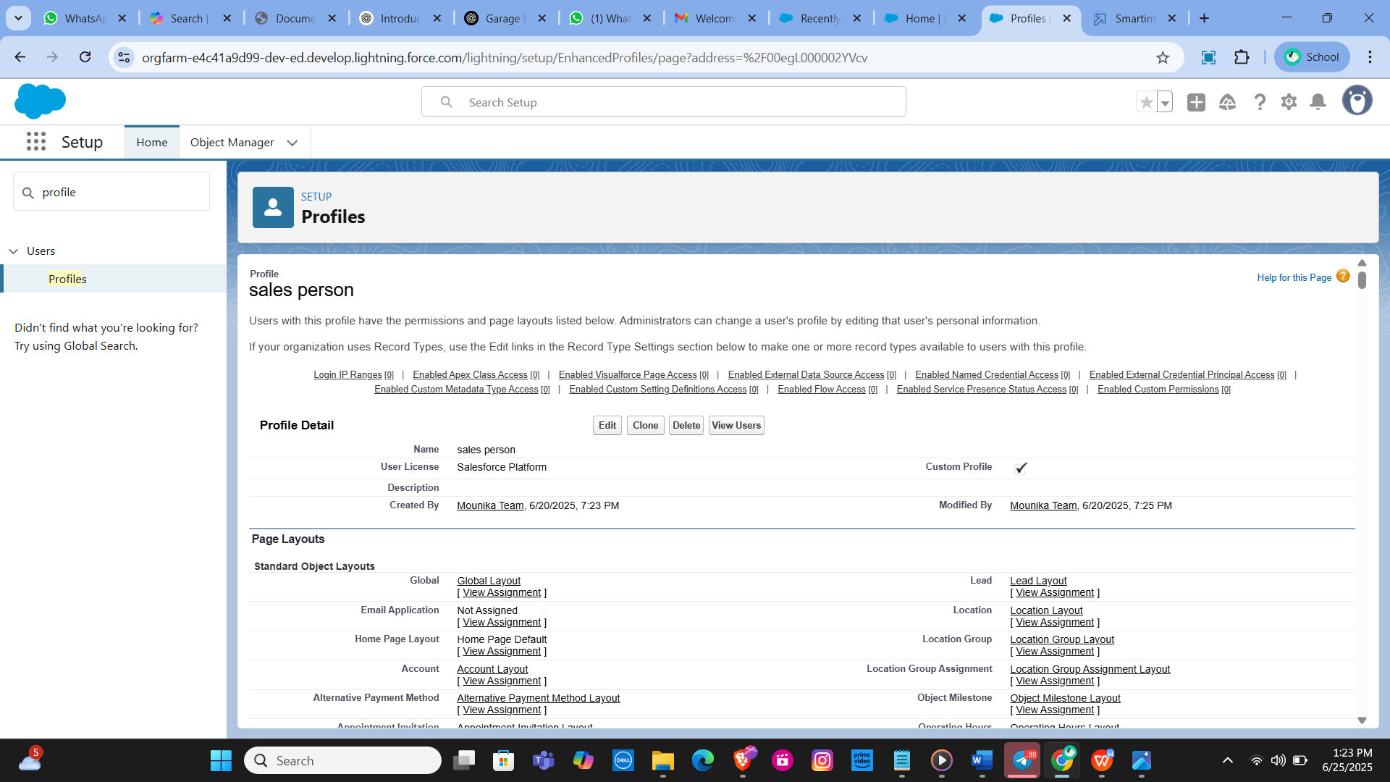

**Task -9**

Role And Role Hierarch

**Creating the Manager Role**

Access Roles Setup: Navigate to the roles setup section in Salesforce.

Expand Role Hierarchy: Expand all roles and add a new role under the appropriate superior role.

Define Role Details: Label the new role as "Manager" and save the configuration.

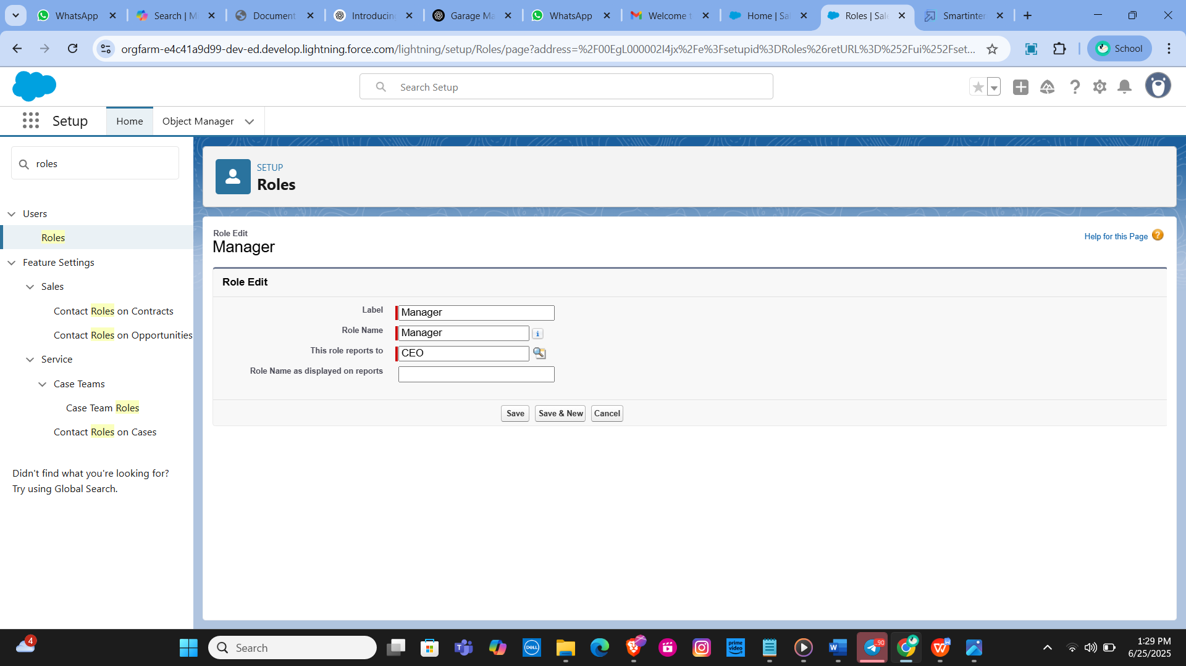

**Creating Salesperson Role**

Access Roles Setup: Navigate to the roles setup section in Salesforce.

Add Role Under Manager: Expand the CEO role and add a new role under the Manager role.

Define Role Details: Label the new role as "Salesperson" and save the configuration.

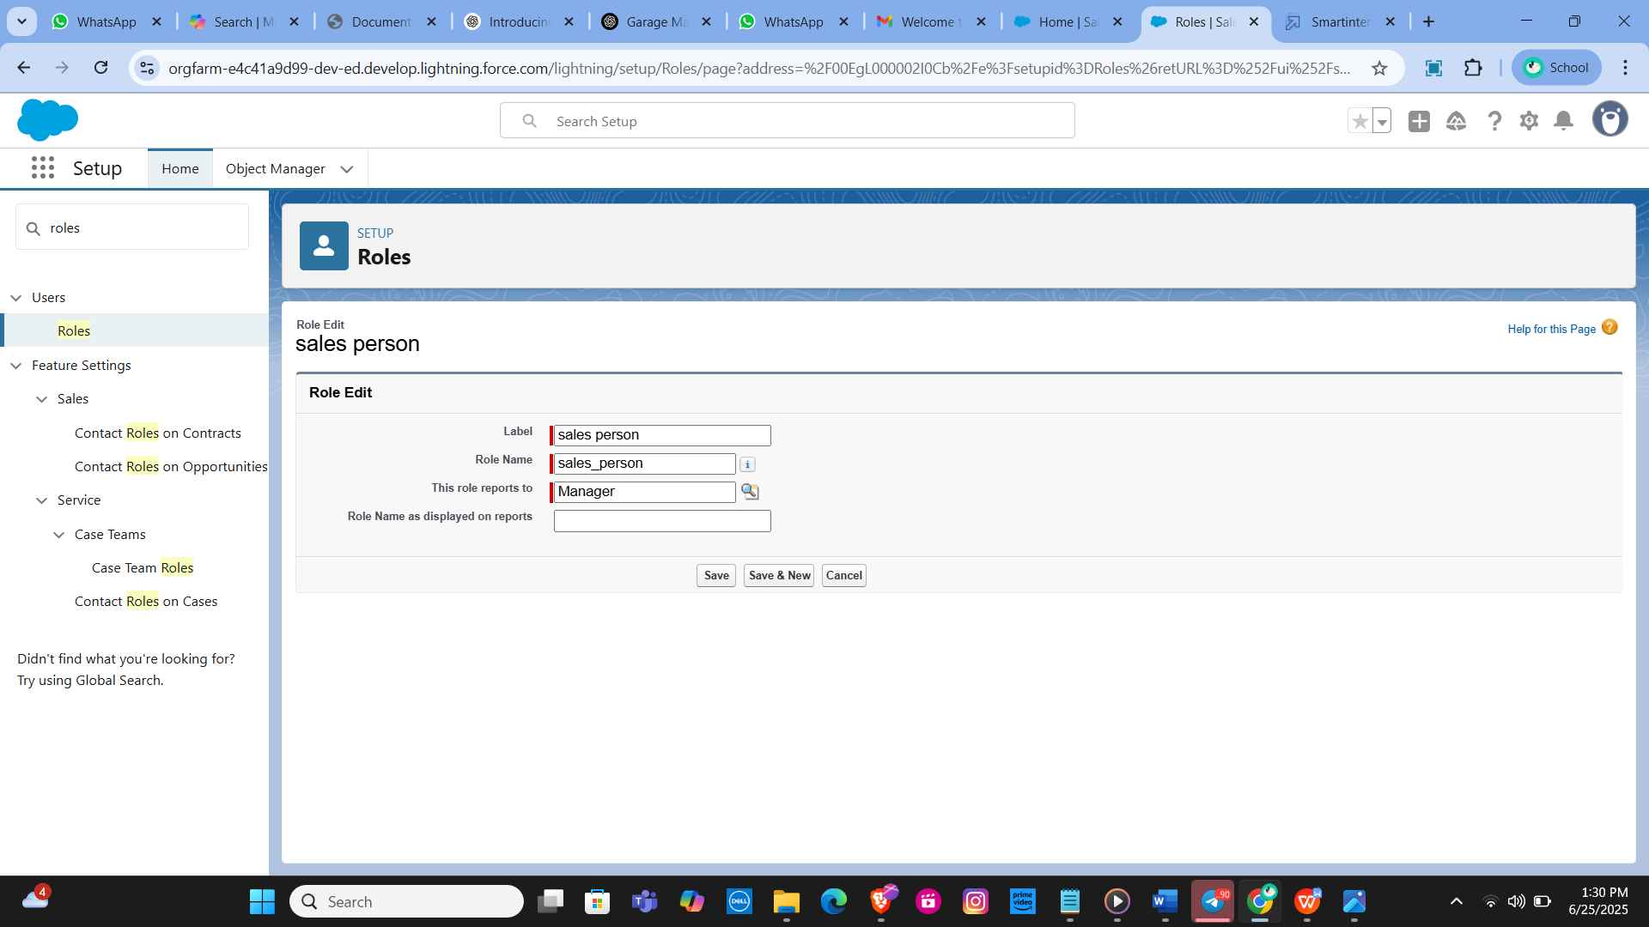

**Task - 10**

**Users**

**Creating a Manager User**

Access User Setup:

Navigate to the users section in Salesforce setup.

New User Details:

Fill in the required fields with the user's details, such as first name, last name, alias, email, username, and nickname.

Assign the role of "Manager."

Set the user license to "Salesforce."

Assign the profile of "Manager."

Save the Configuration:

Save the user details to create the new Manager user.

**Creating Salesperson Users**

Access User Setup:

Navigate to the user's section in Salesforce setup.

New User Details:

Fill in the required fields with the user's details.

Assign the role of "Salesperson."

Set the user license to "Salesforce Platform."

Assign the profile of "Salesperson."

Save and Repeat:

Save the user details and repeat the process to create at least three users with the Salesperson role and profile.

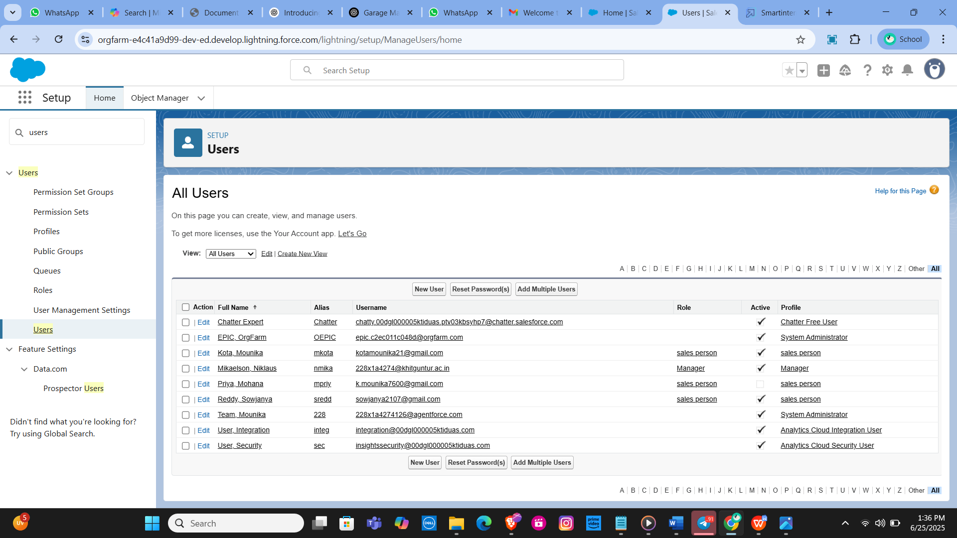

**Task - 11**

**Public Groups**

**Creating the Sales Team Public Group**

Access Public Groups Setup:

Navigate to the public groups section in Salesforce setup.

Define Group Details:

Provide a label for the new group, such as "Sales Team." The group name is automatically generated based on the label.

Add Members:

Search for roles in the available member section.

Select the "Salesperson" role and add it to the selected members list.

Save the Group:

Save the new public group configuration.

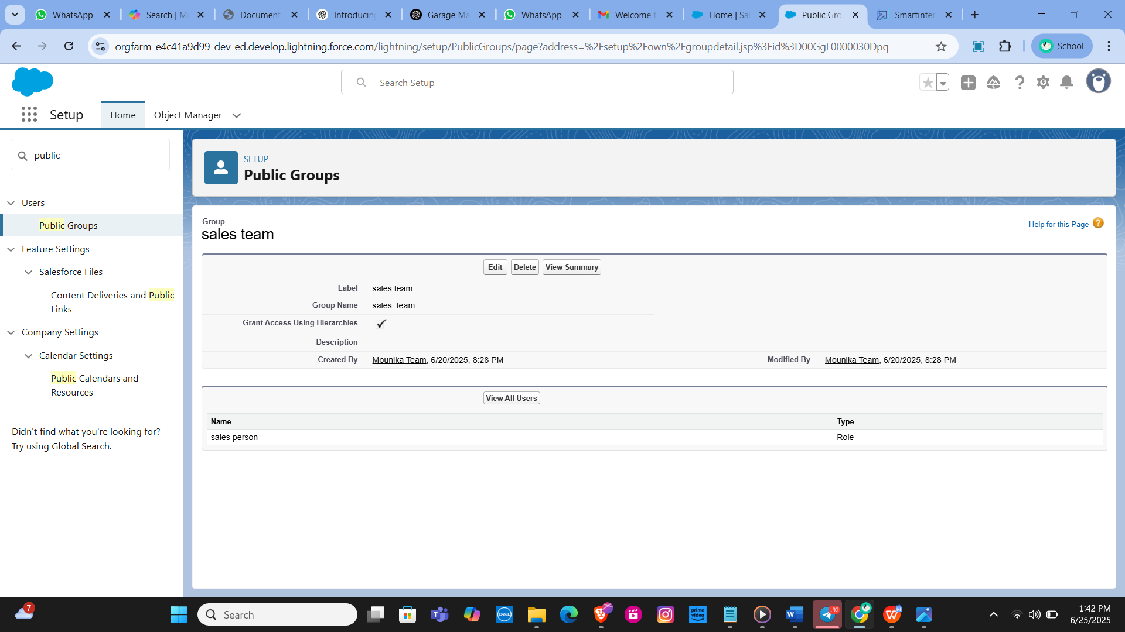

**Task - 12**

**Sharing Settings**

**Configuring Sharing Settings for Service Records**

Access Sharing Settings:

Navigate to the Sharing Settings section in Salesforce setup.

Set Object-Wide Default (OWD):

Change the OWD setting for the Service Records object to "Private" to restrict access to records by default.

Create Sharing Rules:

Define a new sharing rule to grant access to specific roles.

Define Sharing Rule Details:

Label the sharing rule appropriately, such as "Sharing Setting."

Specify the members of the role to be shared, selecting "Salesperson."

Determine who will receive access, selecting "Manager."

Set the access level to "Read/Write."

Save and Refresh:

Save the sharing rule and refresh the settings to apply changes.

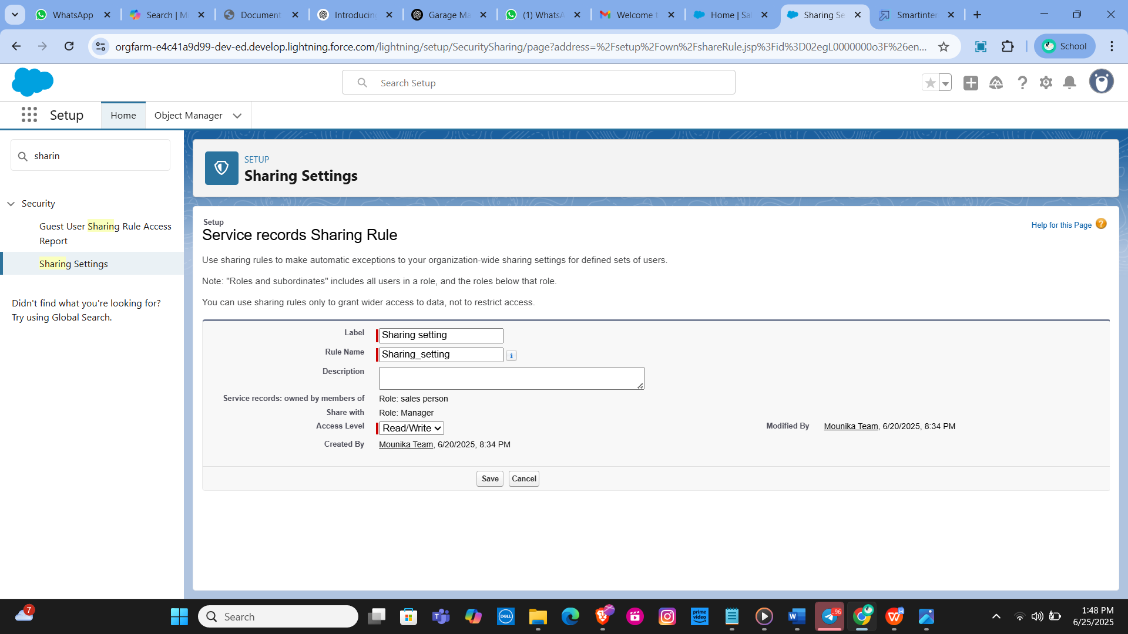

**Task - 13**

**Flows**

**Creating the Flow**

Initiate Flow Creation: Access the Flow setup page and start a new Record-Triggered Flow.

Configure Flow Trigger: Select "Billing Details and Feedback" as the object.

Set the flow to trigger when a record is created or updated.

Choose "Actions and Related Records" to optimize the flow. Add Update Records Element:

Label the update element as “Amount Update.”

Configure it to update records where the field Payment_Status__c equals "Completed."

Set the field value for Payment_Paid__c to the service amount from the related Appointment record.

Create and Configure Email Alert: Define a new resource as a text template to construct the email body.

Use rich text format for clarity and include placeholders for dynamic content. The email body should express gratitude for the payment and include the payment amount. Add Email Action: Insert an "Action" element to send an email. Utilize the previously created text template for the email body. Set the recipient address dynamically from the related record. Define the subject of the email as "Thank You for Your Payment - Garage Management."

Save and Activate the Flow: Save the flow with an appropriate label and auto-populated API name. Activate the flow to make it operational.

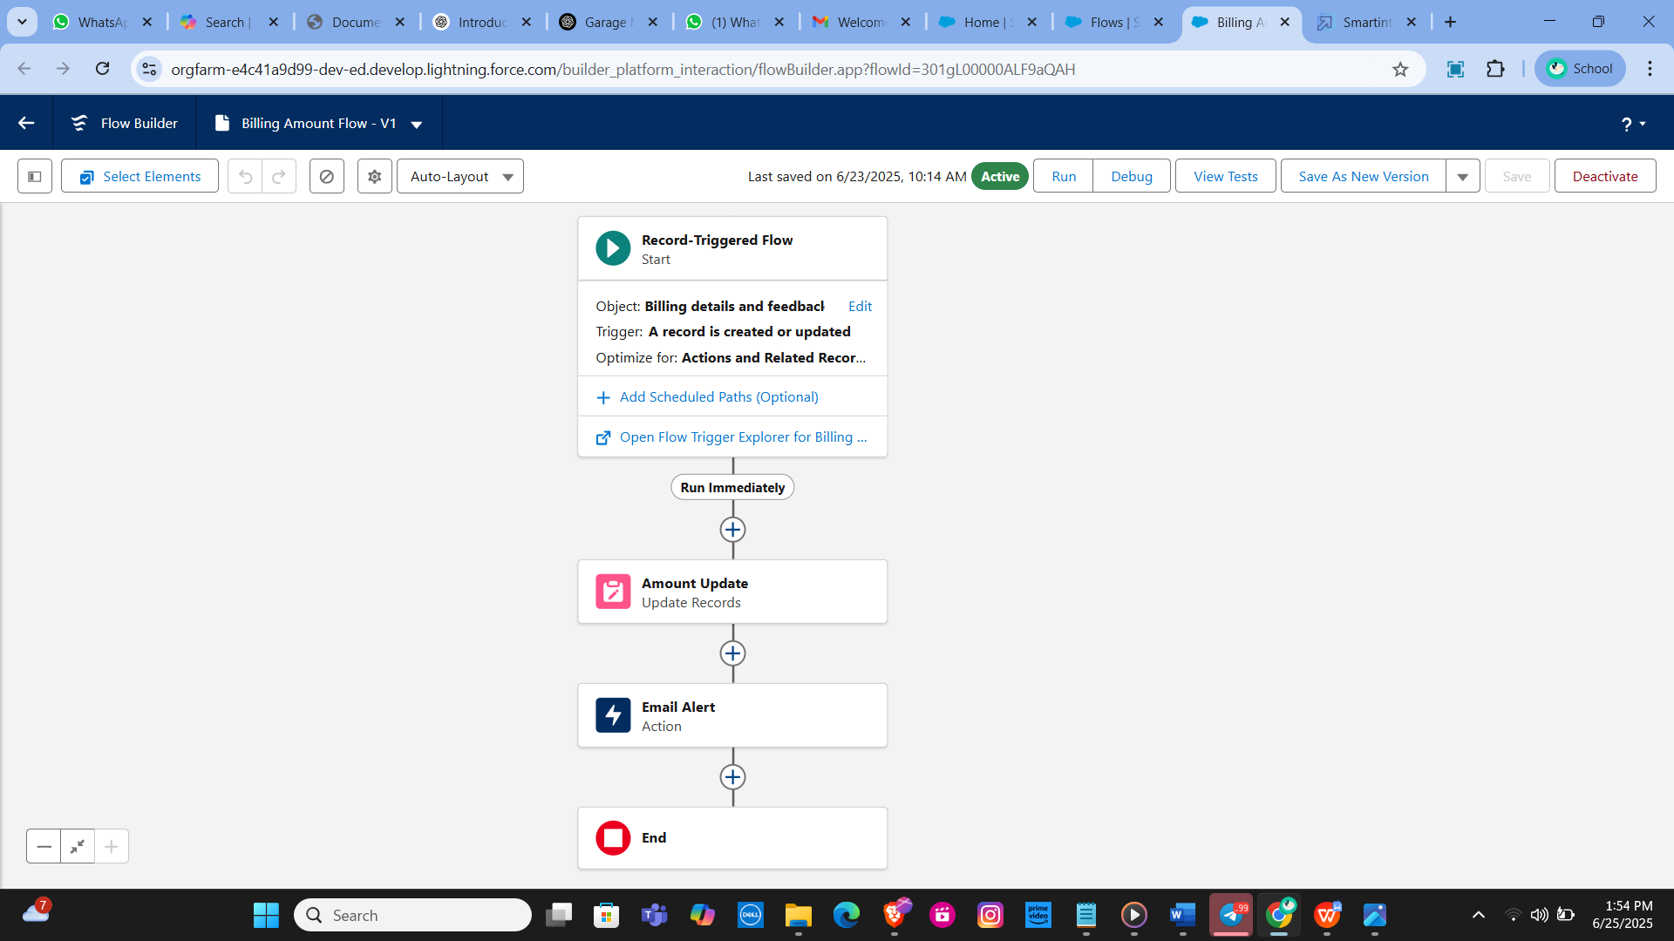

**Task - 14**

**Apex Triggers**

Apex Handler: AmountDistributionHandler

Purpose: This Apex class calculates and updates the service amount based on selected services in the Appointment__c object.

Class Definition:

Class Name: AmountDistributionHandler

Method: amountDist

Parameters: List – A list of appointment records to process.

Functionality: Iterates through the list of appointments. Updates the Service_Amount__c field based on the combination of services selected: All three services: 10000

Maintenance and Repairs: 5000

Maintenance and Replacement Parts: 8000

Repairs and Replacement Parts: 7000

Maintenance only: 2000

Repairs only: 3000

Replacement Parts only: 5000

Trigger: AmountDistribution

Purpose: This trigger invokes the AmountDistributionHandler to update the Service_Amount__c field whenever an appointment record is inserted or updated.

Trigger Definition: Trigger Name: AmountDistribution sObject: Appointment__c

Events: before insert, before update

Trigger Logic: Checks if the trigger event is before insert or before update. Calls the amountDist method from AmountDistributionHandler to perform the required updates on the Appointment__c records.

Code: trigger AmountDistribution on Appointment__c (before insert, before update) { if (trigger.isbefore && (trigger.isinsert || trigger.isupdate)) { AmountDistributionHandler.amountDist(trigger.new); } }

**Task -15**

**Reports**

**Creating a Report Folder**

Objective: Organize reports by creating a dedicated folder. Process: Access the Reports tab through the app launcher.

Click on New Folder and name it "Garage Management Folder".

The folder's unique name is automatically generated. Save the new folder to store and manage related reports.

**Sharing the Report Folder**

Objective: Control access to the report folder.

Process: Navigate to the Reports tab and locate the "Garage Management Folder".

Click on the dropdown menu next to the folder name and select Share.

Choose Roles as the sharing option, search for the "Manager" role, and assign View access.

Confirm the sharing settings and finalize by clicking Done.

**Creating a Custom Report Type**

Objective: Define a report type to include multiple related objects.

Process: Access Setup and search for Report Types. Click on New Custom Report Type.

Set the Primary Object to Customer Details.

Name the report type "Service Information" and confirm the auto-populated name.

Categorize under Other Reports and set the deployment status to Deployed.

Click Next to define related objects: Appointment Object Service Records Billing Details and Feedback Save the new report type.

**Creating a Report**

Objective: Generate a detailed report based on the report type created.

Preparation: Ensure to create at least 10 records for each object to ensure comprehensive data representation.

Process: Access the Reports tab and click on New Report.

Select the category Other Reports and choose Service Information as the report type.

Start the report builder and configure the fields:

Columns: Customer Name, Appointment Date, Service Status, Payment Paid.

Group Rows: Rating for Service, Payment Status.

Add a Line Chart to visualize the data.

Save the report with the name "New Service Information Report", ensuring the unique name is auto-populated and the report is saved in the "Garage Management Folder".

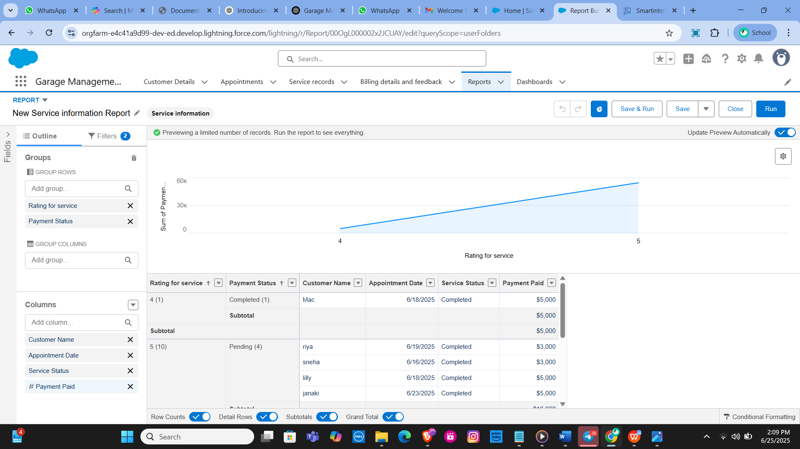

**Task - 16**

**Dashboards**

**Creating a Dashboard Folder**

Objective: Organize dashboards by creating a specific folder.

Process: Navigate to the Dashboards tab via the app launcher.

Click New Folder and name it "Service Rating Dashboard". The unique name is auto-generated.

Save the folder to group and manage related dashboards efficiently.

Sharing the Dashboard Folder

Objective: Set access permissions for the dashboard folder.

Process: Locate the "Service Rating Dashboard" folder in the Dashboards tab.

Click on the dropdown menu for the folder and select Share.

Assign appropriate permissions based on user roles, ensuring that the relevant team members have access to view or edit the dashboards as needed.

Confirm the sharing settings to finalize.

**Creating a Dashboard**

Objective: Build a dashboard to visualize data and insights.

Process: Access the Dashboards tab and click New Dashboard.

Enter a name for the dashboard and select the "Service Rating Dashboard" folder created earlier.

Click Create to start building the dashboard.

Add a new component by selecting Add Component.

Choose a report to base the dashboard on, and select a Line Chart for visualization.

Customize the chart theme as desired.

Click Add to include the component in the dashboard, then click Save and Done.

Subscribing to the Dashboard

Objective: Automate the delivery of dashboard updates.

Process: After saving the dashboard, click Subscribe at the top right.

Set the subscription frequency to Weekly.

Choose Monday as the day for the report to be sent.

Click Save to activate the subscription and ensure regular updates.

